Overview
Today we’ll download some programs we need for ESS. The first is EndNote, a reference management software. This will let you keep track of papers, easily format bibliographies when you write, and more. The second is a programming environment called R, and a nice interface called RStudio. Together these are powerful data analysis and visualization software. You will also want to download the VPN program, which lets you log in to LU resources from off campus.

Please note, these instructions are a work in progress. Please send corrections to kimberly.nicholas.academic@gmail.com.

- Get Online at Lund University
Option 1: Use LUWeblogon network and sign in with Stil account and password (same as you use to access LatL).

Go to Wireless Access page: (In Swedish,
http://www.ldc.lu.se/tjaenster/naetverk/traadloest-naet
Scroll down to Instruktioner för att ställa in krypterad inloggning (802.1x) till eduroam
Click on relevant system (e.g., Mac OSX 10.6, Windows 7, iPhone, etc.)
Follow the instructions there. (Note that this page is a secure link and the link will not work if copied and pasted.)
https://zero.comaround.com/sv-SE/182-1277/
search ”Eduroam” for relevant system.

Install EndNote

http://www.lub.lu.se/en/researcher/reference-management.html
Scroll down to EndNote, click the link ”Student Services”’

- Go to Student Portal: http://www.student.lu.se/uPortal/render.userLayoutRootNode.uP
- Log in with your Stil account and password.
- Note that you can change languages in the upper right corner if needed.
- Go to “My Services” and click “Download software” (left menu).
- Download software
- Scroll down
- Select “Programs for Students”, then the correct operating system (Windows or Mac)
  - Select VPN
  - Eduroam
    - Open Zip file
    - Open .exe file.
    - Extract/open and select folder to place it.
    - Navigate to that folder and open the .exe file.
    - Select language.
    - Agree to terms
    - Leave options as is and start installation.

- Select EndNote
- Download the .zip file.
- Unzip the file.
- Click on the .msl file and proceed with Installation.

R Software Installation

BEFORE the first R lab after Breanäs, you need to download and install the R program on a laptop computer that you’ll bring with you to class every day of the module. Please follow the instructions below. If you have trouble, your first resource is your classmates who have successfully installed the program; after trying that route, I am also available to help you in class.

- Visit http://cran.r-project.org/ and click on appropriate link (Mac or Windows).
- Click on the “.pkg” file on the next page (e.g., “R-2.15.2.pkg”) and choose where to save it (e.g., your Desktop).
- Double-click on the .pkg file on your desktop and follow instructions (select “continue” and “agree”, then “install”).
- Once installation is completed, double-click on the R icon to launch the program. You should get a screen that looks like this:

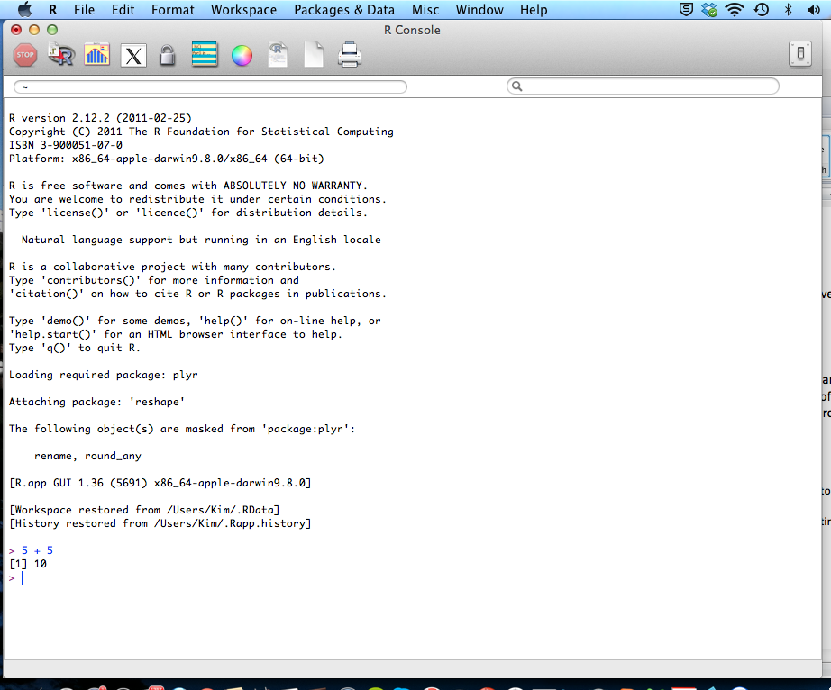

- Try typing “5 + 5” at the command prompt and press Enter. If R responds with “10”, congrats! Everything is working properly and you’re on your way to becoming a coding genius.
- If the language in the screenshot above is something other than English, you need to follow step 9 below. If not, don’t worry about it.
- In this class, we will use RStudio, which is an “integrated development environment” (IDE) that has some nice aesthetic and practical features for working with R, including putting the code file, command console, and graphics output in one place. After you have downloaded and installed the base R program, download RStudio from http://www.rstudio.com/ide. Follow the installation instructions. You should get a screen that looks like this:

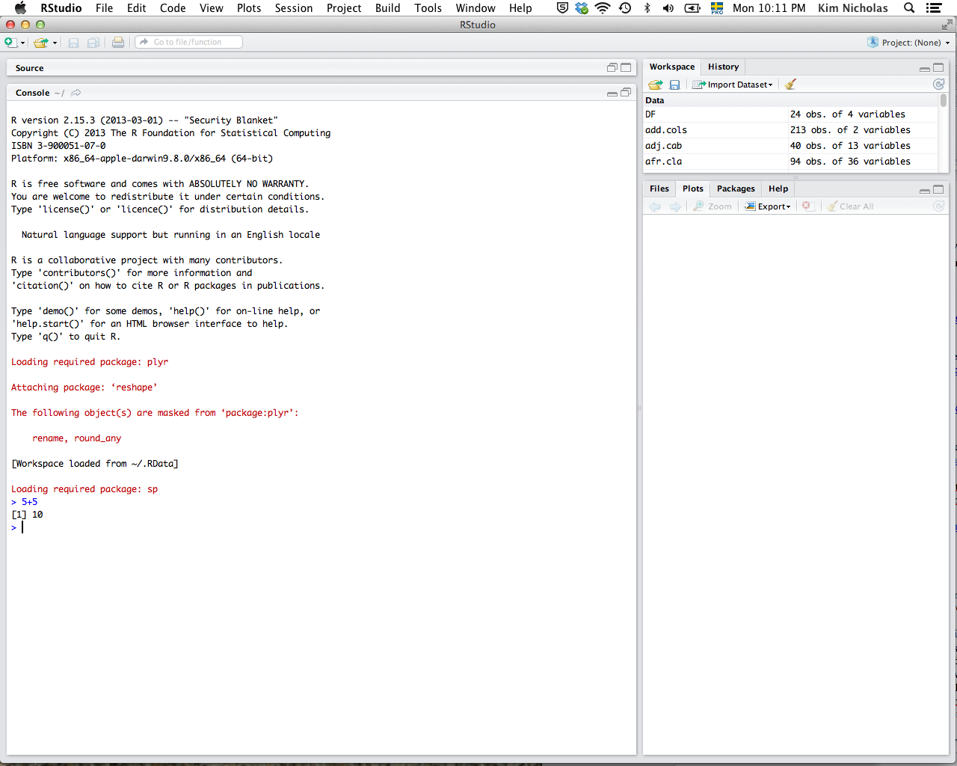

- Again, try typing “5+5” and press Enter. If RStudio responds with “10”, you’re set! Soon you will be on your way to making cool stuff like this:

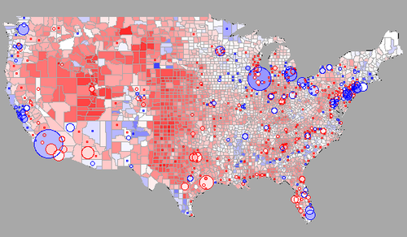

http://blog.revolutionanalytics.com/2009/01/r-graph-gallery.html

Troubleshooting
- If your computer is operating in a language other than English, things will not work properly in R. To fix this:
Windows (*Thanks to Greg Hirson at UC Davis and Ralf Bilke, LUMES MSc 2012, for figuring this out!)

- Right-click on the R icon on your desktop.
- Select “properties” (in your language, usually the last selection).
- Write “LANGUAGE=en” in the first box behind “set target” (in your language, the first box).
- Click on OK (you have to have administrator rights).

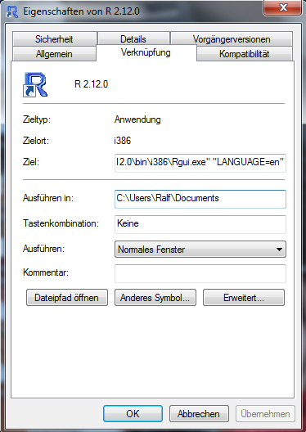

Mac (from R FAQ’s for Mac)
- Open Terminal (Applications ⇒ Utilities ⇒ Terminal)
- At the $prompt, type the following:
defaults write org.R-project.R force.LANG en_US.UTF-8

