Generic Paper Outline
Or, What Goes Where in a Scientific Paper?
Kim Nicholas, Kimberly.nicholas.academic@gmail.com

Draft updated 23 February 2015

- Critical note: You should not sit down and write the paper in the order listed below from start to finish. A suggested order for writing a paper is:

- Research questions/hypotheses
- Methods (can usually take from protocol from the field)
- Results
- Discussion
- Conclusion
- Introduction
- Abstract
- References

The most important point here is, the first major step you should take in writing is to analyze your data, make your figures, and figure out what you have found in your research. This should guide what goes in the rest of the paper, so that the references to larger issues in the literature and other studies relate to what your data actually support. Do not start the process by reading and reviewing hundreds of papers, then writing an Introduction that takes up half your allotted word count, which may in the end have very little to do with what you found.

- Abstract (200-250 words; 80% should be original to your study)
  - The scope of the problem to be investigated (why research is relevant) (1-2 sentences)
  - Purpose of the study/research question (why research was done) (1-2 sentences)
  - Methods (how research was done) (1-2 sentences)
  - Major results (2-3 sentences, give specific numerical values, e.g., we found 53% more blue than green ants)
  - Interpretations of results (1-2 sentences)
  - Implications (1-2 sentences)
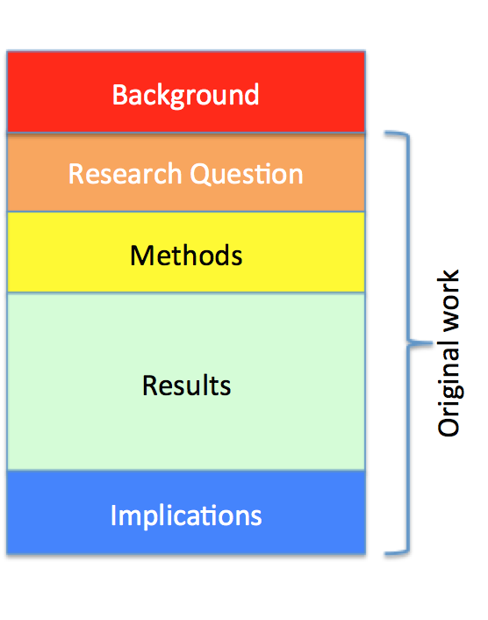
Figure 1: Kim’s suggested structure for an abstract.
- Keywords
  - Do not repeat from title.
  - Use technical terms and phrases from the literature.

- Introduction (300-500 words)
  - Broad topic: general problem and background, motivation (why we should care), reference lit
  - Narrower topic: zero in on specific problem/issue of this paper, including previous research in the area (both geographic and topical as relevant) and definition of key concepts and assumptions; reference lit
  - Conclude with a paragraph that clearly states the research question, purpose of this research.

- Research question(s) (RQs)
  - Should be explicitly spelled out (e.g., in the form of a question)
  - Must be operationalized from general concepts (sustainability, food security) into specific, observable, measurable variables (paper recycling rates, biofuel usage, etc.)

- Methods: Someone could replicate your study by reading this. Needs to answer who, what, when, where, why and how. (ca. 800 words)
  - Case description and selection
    - Subjects/case used
    - Description of field site, relevant physical and biological features, map
    - How were participants selected and/or recruited?
    - Why is this an interesting case- why study this phenomenon in this particular context?
    - Origins of samples and materials
  - RQ1 – use first research question as sub-heading
    - Methods used to answer RQ1
  - RQ2
    - Methods used to answer RQ2
  - RQ3
    - Methods used to answer RQ3
  - When
    - Dates, time periods
  - What & How
    - Protocol for data collection
    - Data analysis- statistical tests, computer programs, significance levels
  - Why
    - Make sure each section links to purpose of answering research question

- Results (1000-1500 words)
  - Organized by research question using sub-headings
  - Data only- no interpretation of what caused patterns
  - Summarized (figures, tables, means, percentages, standard deviations…)
  - Every key result should have a figure, which is then described and supported in the text

- Discussion (Analysis; synthesize whole paper) (1000-1500 words)
  - Re-state research question
  - Interpret findings from Results in light of this question
    - Do results answer RQ?
      - Yes- what does it mean for RQ?
      - No- what would be an alternative approach to answer it? Describe.
    - Do results agree with what others have shown? (go from narrow back to broad by linking your specific findings with theoretical context from Intro)
      - Yes- how do others explain why?
      - No- what’s different about this study?
    - Reflections on this study
      - Possible sources of error
      - How could study be improved?
      - What would next steps be (in this study, in this field)?
      - What are the implications?
- Conclusions (ca. 300 words)
  - Overall main point(s) for readers to remember, restating and summarizing (rather than repeating) key conclusions
  - What you think the data mean, in light of your research question (reasons why you think this are presented in Discussion)

